**DetroitSat Magnetic Field Testing Rig for 1U CubeSat***Scott Scheraga, Matthew Carpenter*

What is DetroitSat?

In short, we are a small group of engineers, designers, and weekend tinkerers with an interest in amateur spacecraft. We formed in, and work out of i3Detroit, Metro Detroit’s largest makerspace. We aim to create low cost, open source satellite components, with the eventual goal of launching the first makerspace-based CubeSat with active attitude control. We hope to share our designs to help lower the cost and invested-time barriers to entry. We encourage other groups to further refine our designs, and let us know what they find!

Concept

The only true way to test how a magnetic-field based satellite attitude control system will behave is to subject it to fields similar to those it will experience in space. To accomplish this, satellite designers big and small utilize devices containing Helmholtz coils. Helmholtz coils are current loops separated by a distance equal to their radius. When current is run through these coils, a zone of approximately linear and uniform magnetic field is created around midpoint between them. Applying this phenomenon in three dimensions using three sets of Helmholtz coils enables designers to generate a range of different fields. For CubeSat applications, this magnetic field can be used for two purposes. The first is magnetometer calibration. The second is the generation of fields to approximate the magnetic environment seen in orbit for magnetorquer- based actuation and pointing testing.

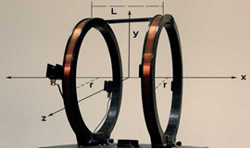

*Fig. 1 – Example of a single axis Helmholtz coil, in this case L = r*

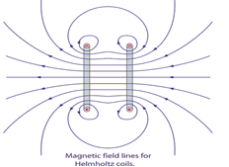

Fig. 2 – Example magnetic field around a set of Helmholtz coils

The greatest benefits of our design are cost and simplicity. Comparable commercial magnetic field testing devices cost several thousand dollars, the materials for this device cost under $50. Also, unlike commercial products which are proprietary, our CAD models, schematics, software, and build instructions are all open source for anyone to build, improve, and share!

Components

The primary structural components of the device are the inner and outer pieces that make up each of the six coil holders (two for each axis). Laser cut from MDF & hardboard, these coil holders are designed to slot together to give the device its shape. The largest pair have flat bases so the device can sit flat on a table. Other laser cut parts include several coil retainers which are used to keep the coil holders in place once they are all slotted together. These pieces can be laser cut out of any sufficiently rigid (non-ferrous) material. We used 1/8” hardboard for the outer pieces and retainers and 1/4” MDF for the centers.

* Target field strength
  + When designing our Helmholtz coil there were many variables to select including coil radius, wire turn count and electrical current per coil. To narrow down the range of these different variables we set a field strength target. Given that the maximum field strength along an axis that a satellite in low earth orbit will experience is ~50µT, we decided to target three times that value. The reason for choosing such a large field strength was to induce sufficient motion using our mockup CubeSat’s magnetorquer in a reasonable time frame while demonstrating at events like Maker Faire.
* Part Names
  + For the purposes of this document the three types of coils will be referred to as large (the outer portions of which are flat to rest on a table), medium (vertical, and perpendicular to the large coils), and small (parallel to the ground). Refer to the images below for a visual representation of the design of each coil type. A complete build incorporates two of each type of coil. Each coil is made up of six pieces in two to three unique patterns. Two of the patterns make up the outer frame of the coil (which prevents the coil of wire from moving axially off the sides of the coil) and one is on the inside (to maintain the roundness of the coil of wire and make sure it is the right diameter). The exploded views below show the construction of the different coil types. The CAD models provided with this document may also be useful. Full assembly instructions can be found later in this document.

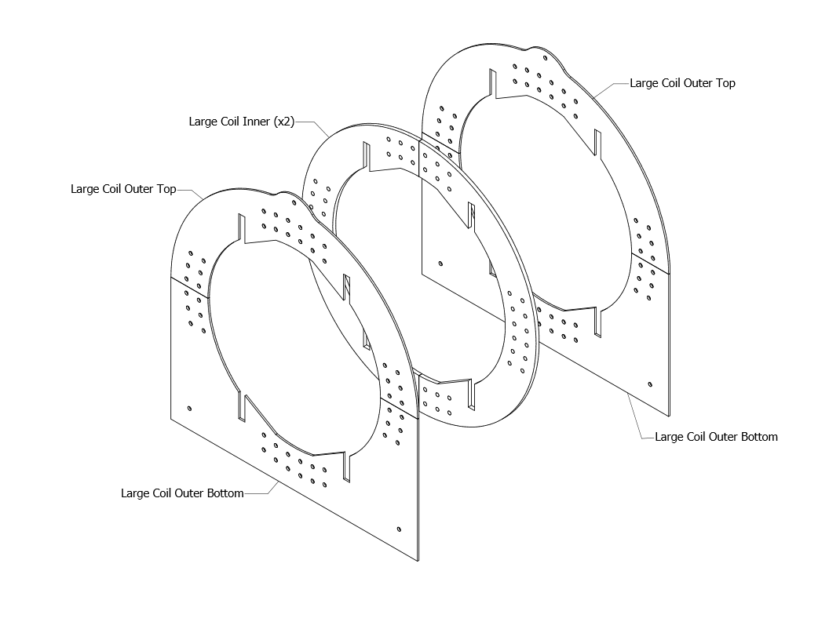

*Fig. 3 – Large Coil Construction*

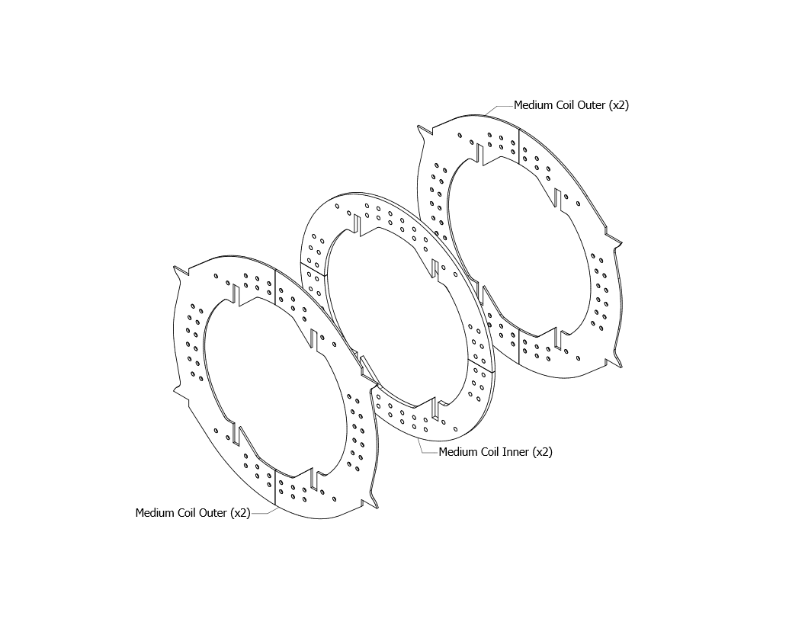

*Fig. 4 – Medium Coil Construction*

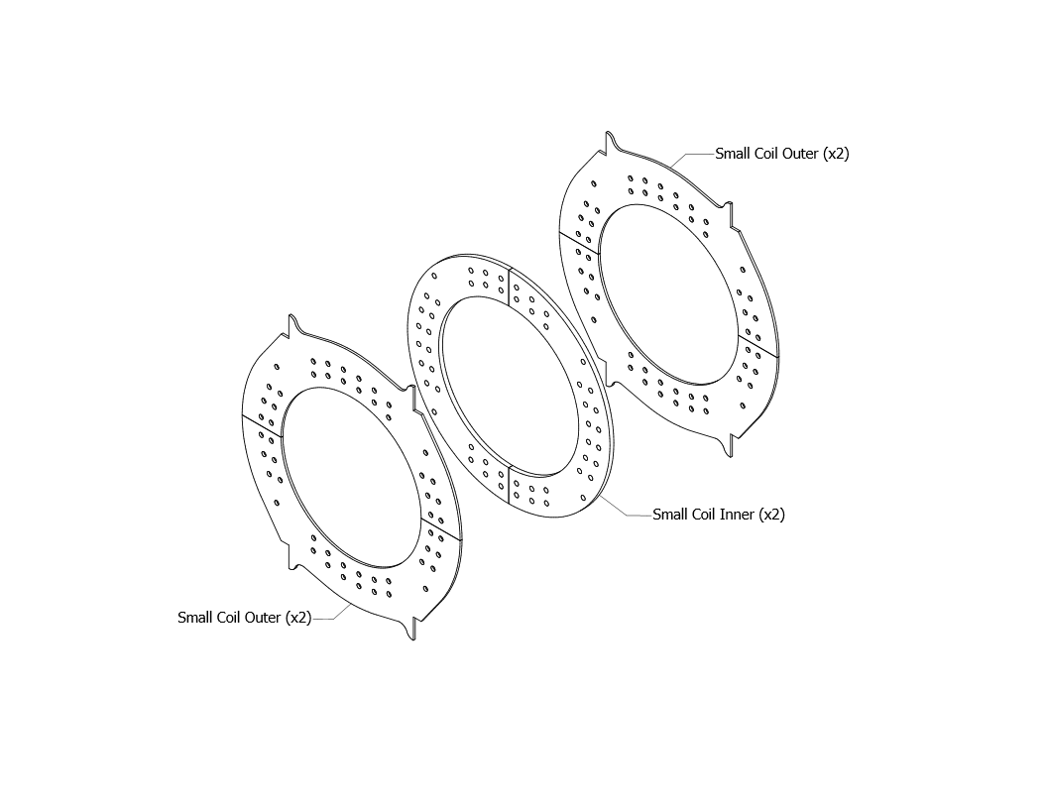

*Fig. 5 – Small Coil Construction*

* In addition to the coils there are also small pieces we will refer to as retainers. These pieces are designed to ensure the coil assemblies, which slot together to form the final device, cannot come apart during use or transport. These retainers come in two different styles. The inner retainers bolt to the small coils and are used to prevent the medium coils from shifting. The outer retainers bolt through the medium coils and keep the medium coils from moving relative to the large coils. Depending on the accuracy of the MDF and hardboard cuts some or all of the retainers may not be needed to keep the design together. With our laser cut parts, we were able to get away with using just the outer retainers. However, it is suggested that at least some are installed if the device will frequently be moved.

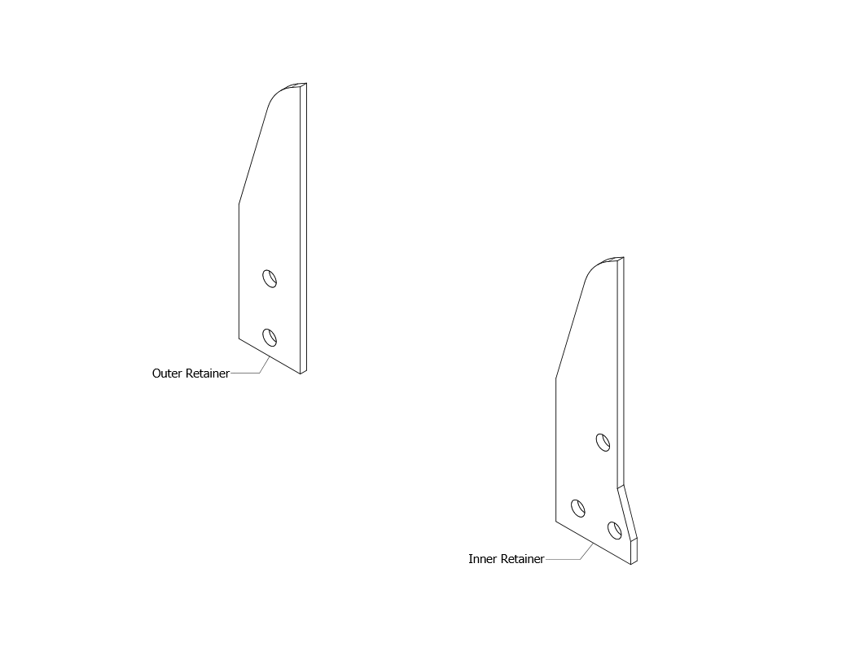

*Fig. 6 – Coil Retainers*

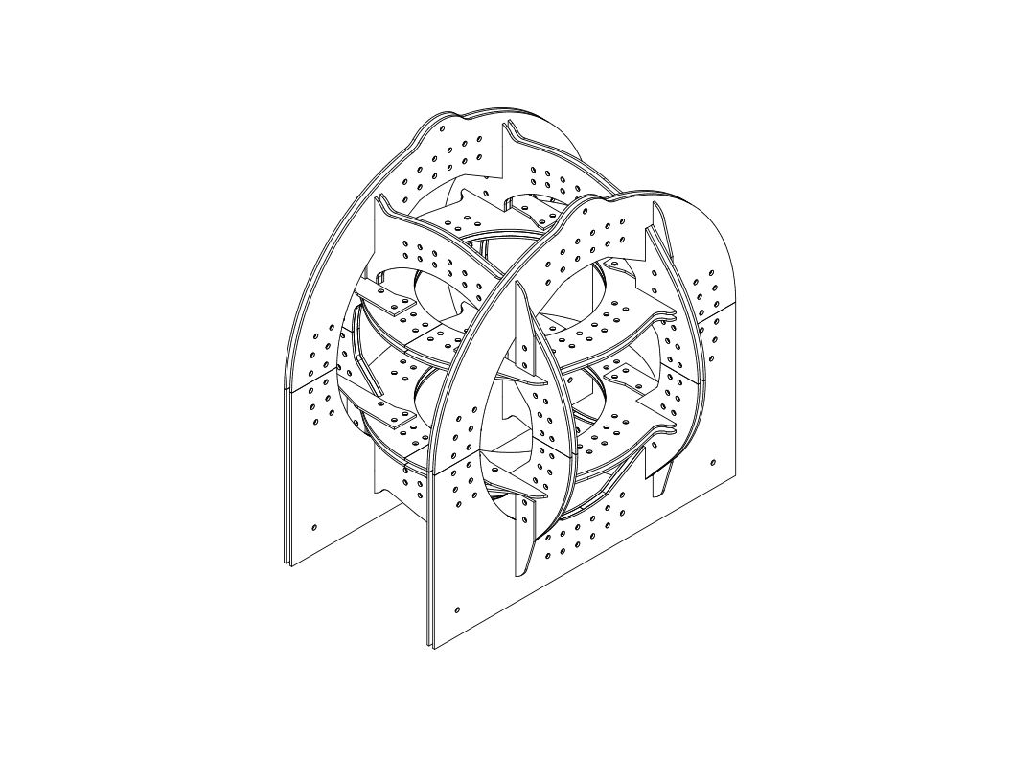

*Fig. 7 – Complete Assembly with All Retainers Installed*

* Future Goals
  + While the current design is a good starting point, there is room for improvements in capability and ease of use while bringing down cost and complexity. For example, the linearity of a field along an axis increases as more coils are added. With that in mind, in the future four coils per axis could potentially improve the operation of the device substantially. An example of the type of design being considered (referred to as a Lee-Whiting coil) can be found in the following paper from Caltech: <http://web.gps.caltech.edu/~jkirschvink/pdfs/coilPaper.pdf>. More coils could be added beyond four but this strikes a good balance between linearizing the field and maintaining a low-cost, simple design.

Assembly

* Tools
  + Laser Cutter – Used to cut all of the MDF and hardboard parts that make up the structure of the device. Talk to your local hackerspace!
  + 7/16” Socket and Combination Wrenches
  + Crimping tool
* Hardware (maximum recommended)
  + 100 ¼-20 ALUMINUM Hex Nuts
  + 88 ¼-20 ALUMINUM Hex Bolts
  + 12 Ring Connectors (at least ¼” inner diameter)
* Notes
  + Don’t worry about the wires and tape on the coils in some of the images. The wires will be explained near the end of the instructions and the tape labels were for our use!
* Assembling Coil Frames

1. Using figures three through five as a guide, match the outer and inner portions of each coil to make assembly easier.
2. For added strength, the inner and outer coil pieces are designed to attach so that the seams are not lined up. When assembling the large and medium coils lining up the slots the other coils fit into guarantees this. However, when putting together the small coils the assembler must pay attention and ensure the seams on the inner and outer coils are perpendicular.

* Many bolt holes are cut into the panels that make up the coil frames. While we initially designed all of the holes to be used for bolting the frames together, we ended up only bolting the outer pair of bolts at each connection. (See figure 9) We recommend keeping the other holes in your lasercut pattern for weight reduction.
* Turning Coils

1. Cut the slits the wire goes through.
2. Either use painters tape or a thin layer of hot glue to block the edges of the wire channel. It is very easy for wire to get stuck in the seams during coiling. See diagram below:

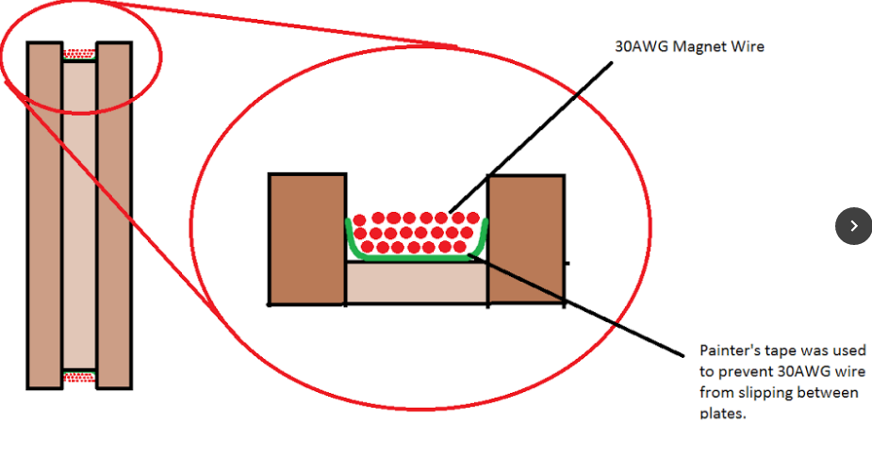

1. Pass the end of the magnet wire through one of the two slits and wrap the exposed wire fully around the exposed shaft of the bolt. When this is complete, add another nut to hold the wire in place for the time being. –

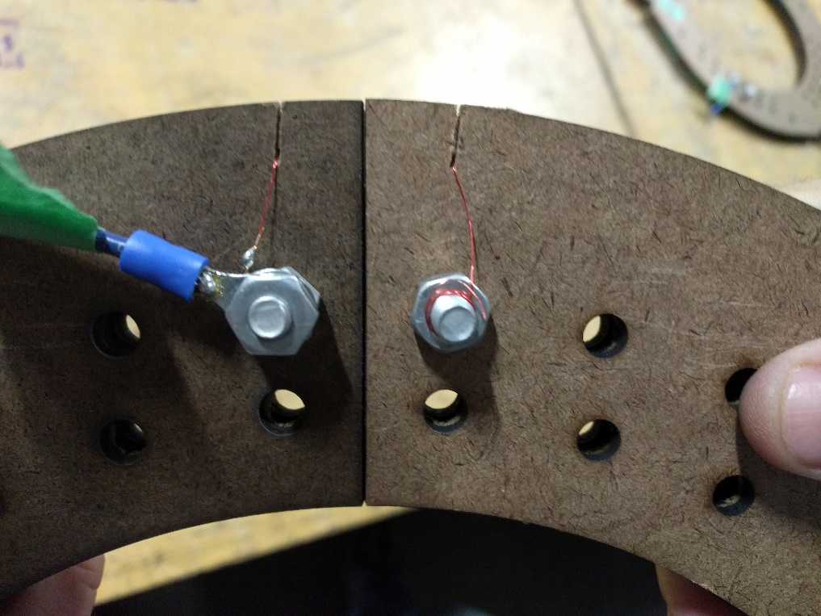  
*Fig. 8 – Magnet Wire Wrapped Around Bolt*

1. Wrap the magnet wire around the coil the required number of times. As seen in the diagram below, we started with point B, and went to point A. Cut the wire leaving several inches to be wrapped around the second bolt. Repeat the process with the hobby knife from step two. 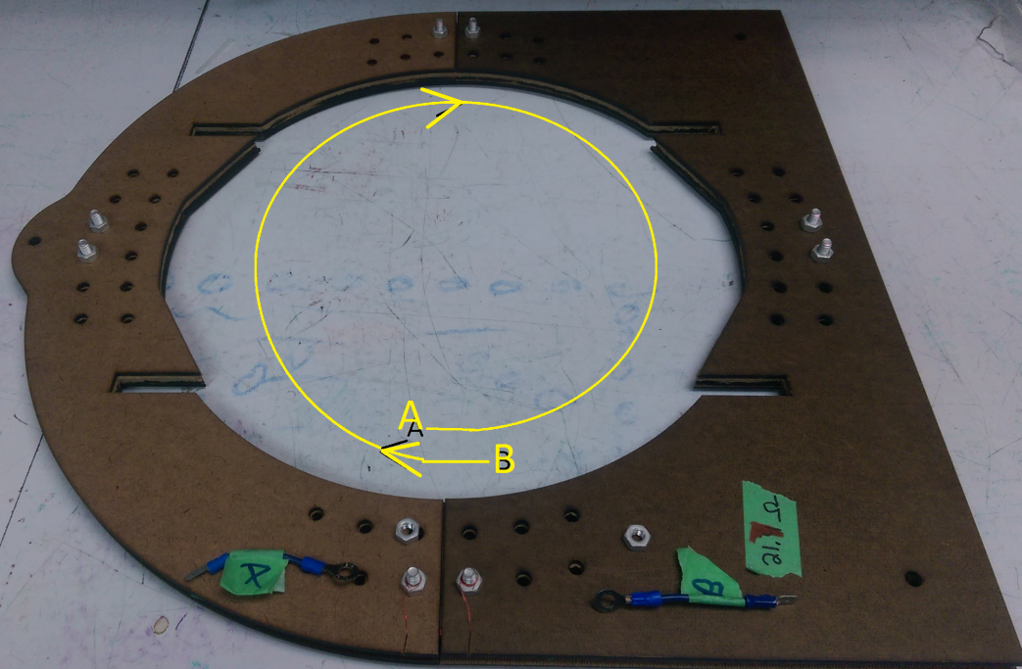

The wound coil channel should look like this when complete:

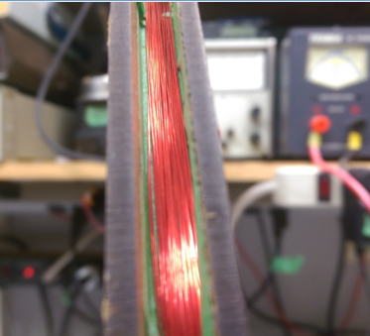

1. Last step – Finally, slide the wire through the second slit you cut into the outer wall of the coil assembly in step one and wrap it around the other bolt the exposed wire fully, add another nut to hold it in place, on top of any connectors that you use.

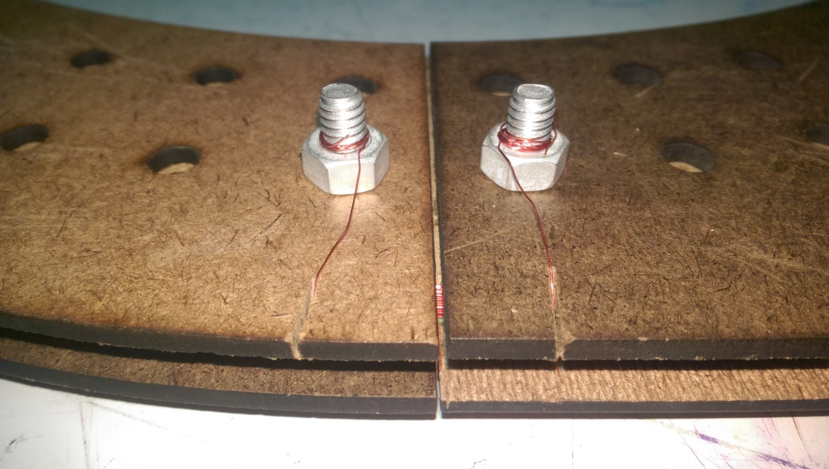

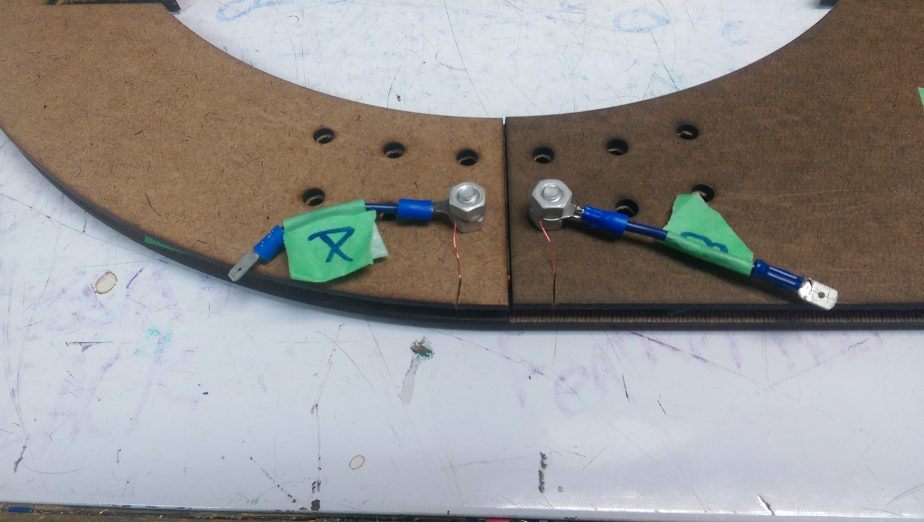

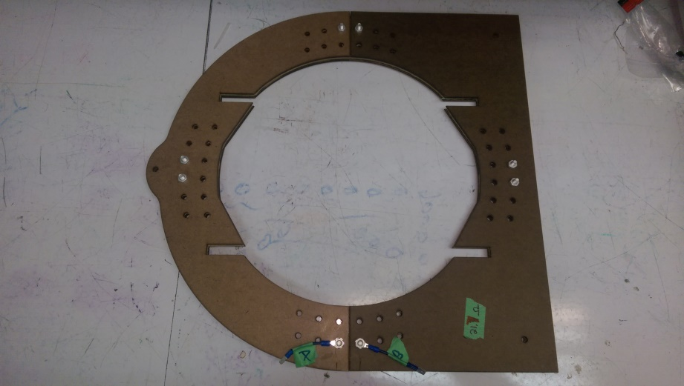

* Final Assembly

1. To begin the final assembly process, take one of the medium sized coils you assembled in the previous sections and place it on the table.

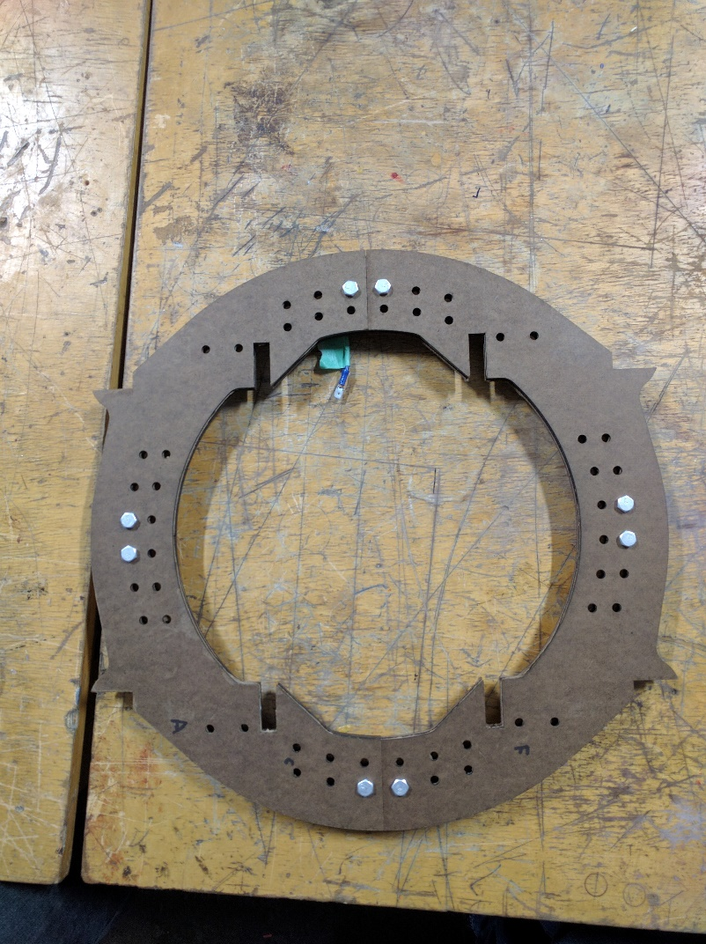  
*Fig. 9 – First Medium Coil*

1. Next take the two small coils and slot them into the medium one as shown. Don’t worry if they are not perpendicular at this point, the next step will take care of that.

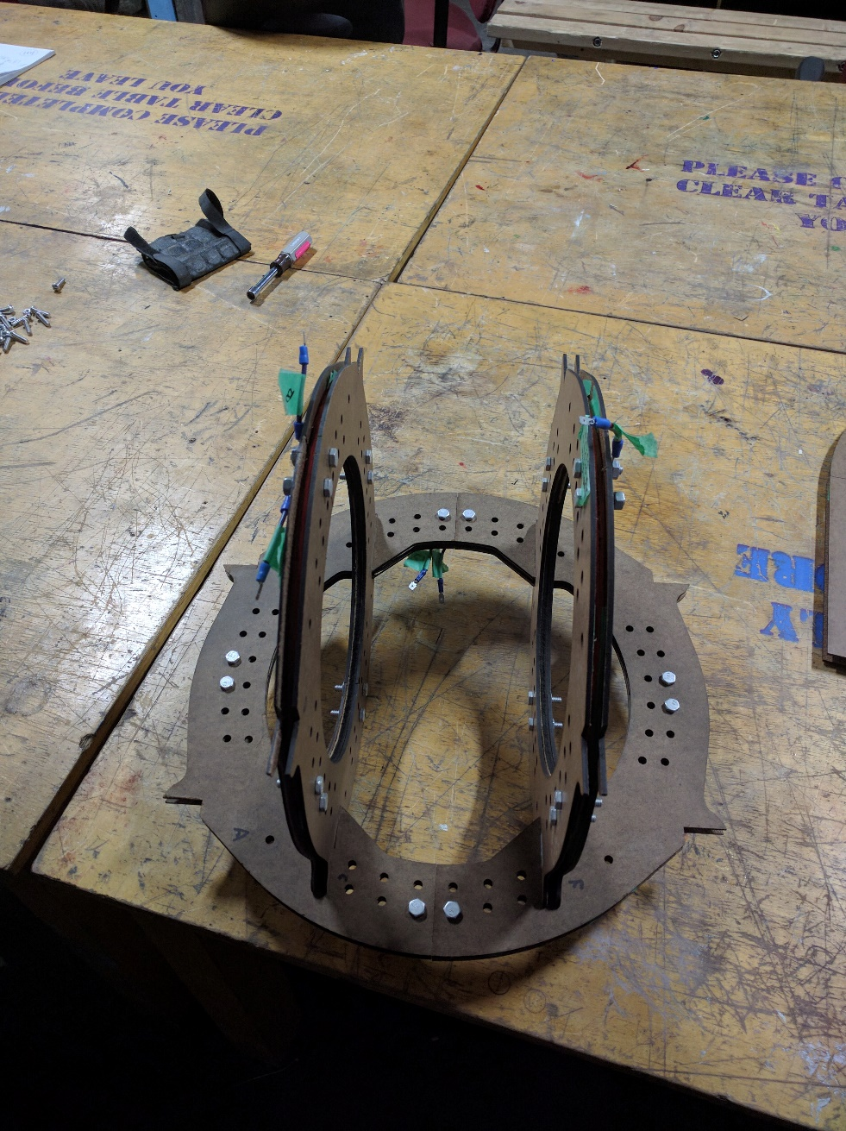  
*Fig. # – Medium Coil with Both Small Coils Installed*

1. Install the second medium coil. Be sure that the small coils slide all the way into the slots of the medium coil.

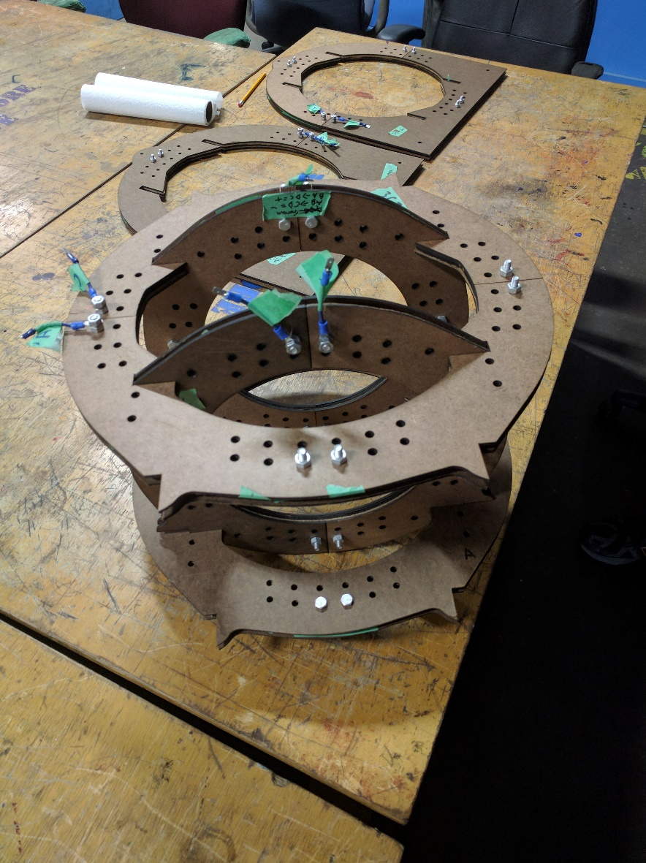  
*Fig. # – Both Medium Coils and Small Coils Fitted Together*

1. The last two coils can now be added. Be sure that the flat sides of the large coils are oriented the same direction and slide them onto the current assembly. Again, be sure that the fins on the medium coils fully seat into the slots in the large coils. This ensures maximum rigidity.

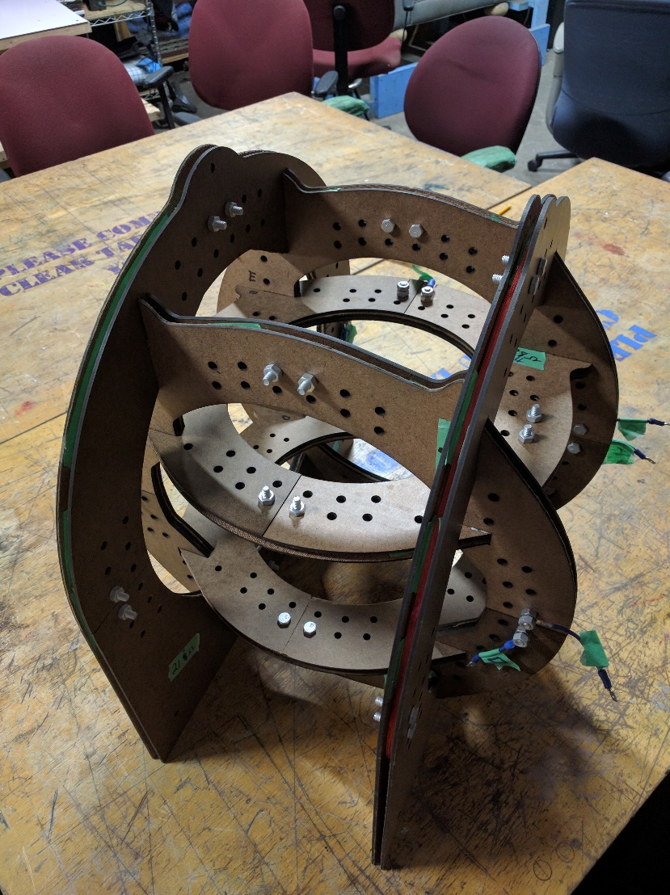  
*Fig. # – Complete Assembly Minus Retainers*

1. Now that all the coils have been slotted together it is time to install the retainers. Depending on the accuracy of your laser cutter and other factors some or all of these retainers may not be necessary for your build. However, we will still briefly discuss their installation.
2. The inner coil retainers bolt to the small coils with their long, flat edge against the outer-facing surfaces of the medium coils. Though these retainers have three bolt holes, only two bolts should be required. Which two holes are used is not important, pick your favorites!
3. The outer coil retainers attach to the medium coils with their longest flat side pressed against the outside faces of the large coils. Bolts need to be installed through both holes in each of these retainers.

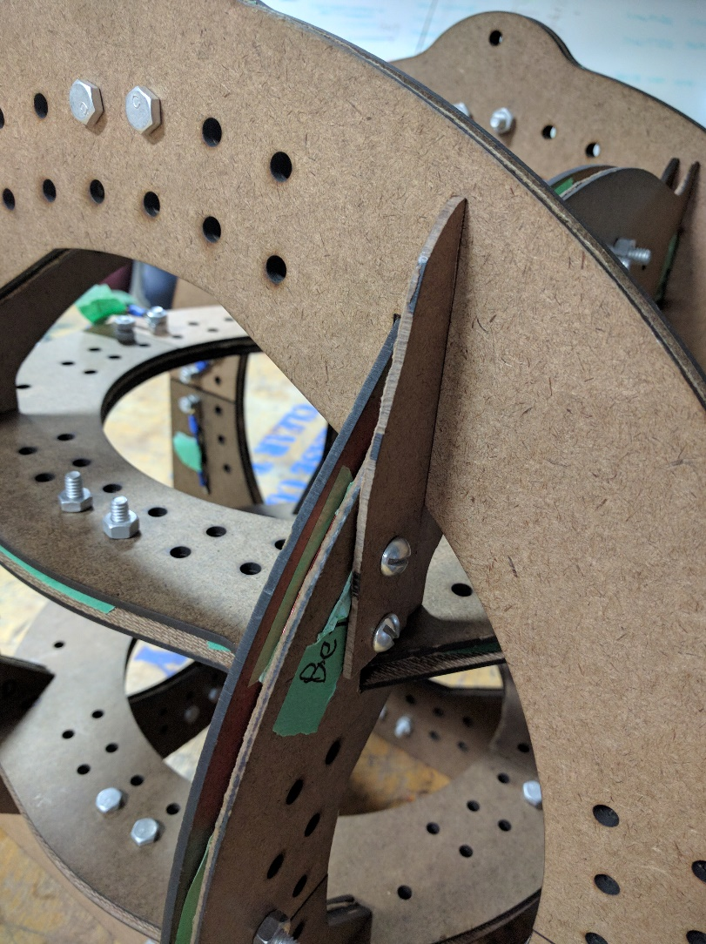  
*Fig. # – One of the (up to) Eight Outer Retainers*

* Wiring – Coils

1. It is important to be sure the current in the coils that make up each axis runs in the same direction. This ensures that the fields created by the two coils interact constructively rather than destructively to have the largest net effect possible. For this reason, now would be a good time to go through and label which end of the magnet wire is “positive” and “negative” for each coil.
2. Each pair of coils is connected in parallel. This is done to simplify control circuitry and wire layout. The common “positive” and “negative” leads will be connected to the control circuitry. To do this we created Y-connectors using two ring connectors large enough to slide over the bolts. Once this is done the nuts that were used to hold the magnet wire looped around the bolts in place can be removed, the ring connector placed over the bolt, and the nut replaced.

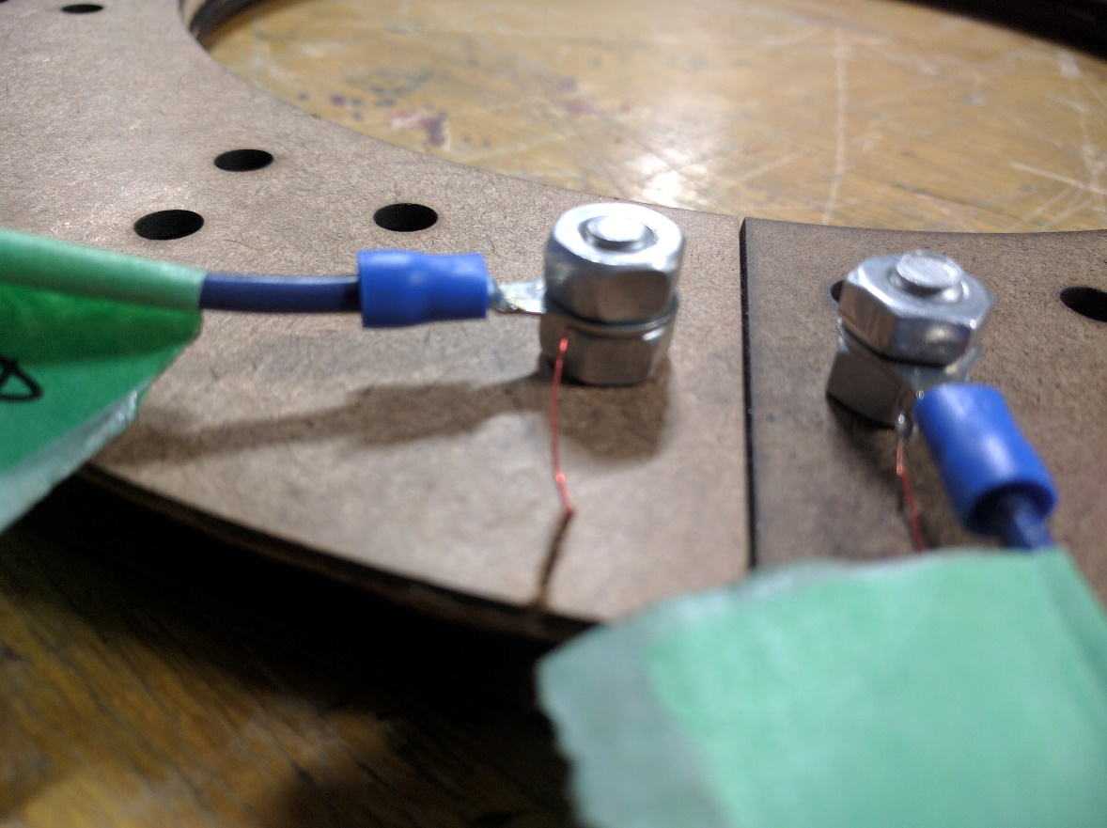  
*Fig. # – Ring Connector Secured with Nut*

Getting in Touch with Us

* Website – detroitsat@gmail.com

Acknowledgements

We would like to take a moment to thank the groups who have helped us get to this point in our project and continue to provide support as we move forward. Some provided monetarily, others were generous enough to have posted their own designs on the internet to help groups like us. Still others, like Nate Bezanson and Andrew Meyer listened to our ramblings and were always willing to answer our questions and provide clarification when we needed it. Finally, we would be remiss not to mention the excellent community at i3 Detroit who has covered all the support types mentioned above and then some. Thank you!

$50 Sat people? Other groups whose documents we read?

Resources

Fig. 1 – Single axis Helmholtz coil example courtesy of UCLA Physics and Astronomy Instructional Labs: <http://demoweb.physics.ucla.edu/content/experiment-6-charge-mass-ratio-electron>

Fig. 2 – Diagram of magnetic field in/around Helmholtz coil thanks to HyperPhysics: <http://hyperphysics.phy-astr.gsu.edu/hbase/magnetic/helmholtz.html>